

Maine Lions District 41

Vision Screening Manual

April 2018

TABLE OF CONTENTS

Why we do Vision Screening ……………………………………………………………………………. 3

How to Use this Manual ………………………………………………………………………………….. 4

Vision Screening Procedures - Step by Step for Lions ……………………………………….. 5

Items needed for your Vision Screening Event ………………………………………………….. 7

Tips for a Successful Screening ………………………………………………………………………. 8

How to interact with children safely and effectively …………………………………………… 8

Sample Letter of Introduction to the School …………………………………………………….. 9

Sample Enclosure for the Introduction Letter ……………………………………………….….. 10

Eye Screening Consent Form ………………………………………………………………………….. 11

Vision Screening Results ………………………………………………………………………………… 12

Vision Screening Tally Sheet …………………………………………………………………………… 13

Vision Screening Results Sheet ……………………………………………………………………….. 14

The following are located on the Vision Screening Page on MaineLions.org
Appendix – Spot User Manual Link
Appendix – Plusoptix Training Video and Manual Link
Appendix - Kidsight USA Stickers – Avery Label (5160)
Appendix - Lions Vision Screening Program Sticker (Avery Label 22808)

Why we do Vision Screening?
The goal of Vision Screening is to provide early intervention in correcting eye disorders. This is a good public relations tool for both your club and for Lions as a whole. It will provide an opportunity for parents, teachers, staff, etc. to learn who the Lions are and what they do for their community. You may find new members among these people.

This is the perfect project to provide a club with a WE SERVE opportunity instead of WE SELL project. Club members will experience a feeling of satisfaction in serving their community and getting closer to them.

This project is a rewarding, fun, and an easy public service event that requires a low level of physical activity and can be accomplished with just a few Lions for each screening. A support team from the Vision Screening Committee is available to assist in getting the club started, and there are other clubs who are willing to mentor clubs new to the program.

It is something that can be done on a regular basis.

Ever since Helen Keller addressed the Lions Club at our 1925 International Convention, and challenged us to become “knights of the blind,” vision preservation (and accommodations for those with vision problems) has been a main focus of Lions Clubs around the world.
Approximately 5 million children in the US will suffer permanent vision damage, uncorrectable with glasses or contact lenses. Sadly, most vision screening for young children occurs too late in life for corrective treatment, and many eye disorders that cannot be determined through the typical use of eye charts are often missed. While the eye charts measure for visual acuity, our vision screening process quickly screens children with a screening camera system that can identify eye disorders such as near-sightedness, far-sightedness, astigmatism, eye misalignment (strabismus), unequal refractive power (anisometropia), and unequal pupil size (anisocoria).
This is done without the need for eye drops or cumbersome head restraints. The process is child friendly and non-invasive. Effective vision care and screening can prevent future learning and behavioral problems.
This type of testing is not provided by anyone else.

We hope you will review the documentation provided and contact a Vision Committee member to help you get started.
Maine Lions/Kid Sight USA Vision Screening Committee
How to Use this Manual
This manual is designed to be your guide in setting up and performing a Vision Screening in your area.
The forms included in this manual may be cut and pasted into a new document. Then you just need to change the various names and locations to suit your needs. We advise that you do not make changes to the disclaimers on the consent form and the screening results sheets.
When you have completed the screening, it is important that you complete the Vision Screening Results Sheet and send it to the Coordinator of the Maine Lions/Kid Sight USA Vision Screening Committee.
If you have never done a vision screening or if your club does not currently have a vision screening machine, but you are interested in performing a Vision Screening in your area, please contact the Coordinator of the Maine Lions/Kid Sight USA Vision Screening Committee. That contact information is available in the District 41 Directory. The Vision Screening Coordinator will provide you with a Vision Screening Mentor.
To view the District 41 Directory online, go to http://www.mainelions.org/.

Vision Screening Procedure - Step by Step for Lions
- Contact the Vision Screening Committee Coordinator to arrange for your Lions to be trained on the use of the vision screening equipment.
- Review the Maine Lions Vision Screening Manual.
- Attend training on the use of the Vision Screening equipment.
- Decide what school, head start, or day care you want to offer a Vision Screening.
- Send a letter of Introduction to the school/facility. (See Sample Letter in Vision Screening Manual Page 9)
- Schedule the Vision Screening at the school’s or facility’s convenience.

Two Weeks before the scheduled screening
- Visit the school for pre-screening visit. Review the room where the screening will take place for lighting (low lighting is best for the optimal camera operation), and available power outlets. The room should be a quiet, area with low stimuli (no toys, low noise and traffic, etc.)
- Provide copies of the Vision Screening Consent form (Page 11) to the school/facility to be distributed to parents. The forms must be returned by the day of the screening.

On the day of the screening
- Collect the required items needed for the Vision Screening (see list on page 7).
- Arrive at the school at least 30 minutes before the screening is scheduled to begin to allow time to set up. (See Appendix for setup information for the type of screener you are using)
- School contact/parent volunteer or a Lion brings 4-5 Children at a time to screening area.
- Match the name of the child with the consent form.
- Introduce yourself and have the child sit or stand in the designated location.
- Ask the child to look at the lights or the smiley face on the device.
- Image is taken.
- Print results (or use thumb drive to export screening results and give to nurse/school representative)
- The results sheet of each student screened should be provided to the school nurse or representative so they can distribute to the parents.
- Give child a sticker and have them return to the school contact person. (See Appendix for sticker layouts.

Vision Screening Procedure - Step by Step for Lions (cont)

After the screening
- Send completed Vision Screening Results sheet to the Vision Screening Committee Chair.
- Send a thank you note to the school/facility representative you worked with at the screening.
- When working with preschools and daycares, use the information on the consent form to follow up with the parents of the referred children to see what the outcome of their follow up visit to the doctor was, or if they need assistance.
- When working with schools, follow up with the school nurse to determine the results of the follow up with the doctor for referred students and to offer assistance as needed.
- Provide publicity after your screening. Let your community know about the details of your event, including the number of persons who benefited from the free screening. Use social media to highlight your event.

Items needed for Your Vision Screening Event

- Screening Team – 2-3 Lions, preferably men and women
- Vision screening machine, printer, and power cord (fully charge)
- Small desk/table (provided by school) for printer
- Small room with controlled, low lighting (provided by school)
- 1 adjustable rolling chair for screener (provided by school)
- 2 stationary chairs one for child and one for the person recording results (provided by school)
- Electricity/Extension Cord/Power Strip with multiple plug-ins
- Duct tape to safely secure extension cord to floor
- A couple of pieces of poster board to block out windows if necessary or colored sheets or blankets to make a tent if necessary to dim the room.
- Masking Tape to secure signs or poster board on the walls
- Name tags and business cards
- Consent Forms (both completed and extra blanks)
- Results Letters
- Result Tally Sheet
- Stickers to reward children for participating and advertise Lions.
- For SPOT cameras, get the list of children ahead of time so they can be loaded into the screening device.

How to interact with children safely and effectively

- Make it “FUN”.
- Never be alone in a room or confined space with a child.
- Have a teacher, school nurse, or teacher’s aide help line the children up and keep them occupied until it is their turn.
- Smile at the children all the time.
- Do not show frustration if a child is not cooperating. Retest on another day if necessary
- Always tell the children they “did a great job”.
- Do not touch children. If they need direction in standing/sitting in the proper location by touching their shoulder have the school personnel do this. Do not do this yourself.
- If you give out stickers for the child to wear after the screening you should hand it to them so the child can place it on him or herself. You may hand the sticker to the school personnel for placement. Do not place it on the child yourself.

Tips for a Successful Screening

- Screeners should dress in flat comfortable shoes, top, and slacks (no shorts or skirts)
- Wear your Lions vest or other Lions apparel and your name tag.
- Be efficient
- Get name and contact info of location’s representative
- Pre-screen location
  - Adjustable low lighting
  - Power
  - Testing location – room with low stimuli (quiet area, no toys, etc.)
  - Work “tent”. Some schools have these for small gathering areas.
- Be prepared before the children arrive
- Arrive at least 30 minutes before screening to set up and make contact with the locations’ representative.
- Lion Screeners should be positive people who enjoy dealing with children. They should be able to make the children feel comfortable.
- Avoid Distractions like too many people in the room
- Roles for Lions
  - Liaison with school – handles check in and helps with the flow of children to and from the testing area (may be a school staffer/volunteer)
  - Vision Screening Operator
  - Recorder – Handles printing and recording documents
- Four to five children can be brought to an outer room with supervision to wait their turn.
- The screening area should place the child that is being screened so they are not facing the door or another light source. The screener should not be facing the door.
- If there is too much light, have the child “salute” over their eyes to reduce the light on their eyes.
- Speak to the school representative to have the more confident children do the screening first.
- Children with glasses can be screened. This should be indicated on the notes and on the screening device.
- Children should not be screened unless a signed consent form for that child is in hand.

_________ Lions Club
PO Box xxx
Your Town, ME 04000

Date

Superintendant’s Name
School District/RSU
Address
City, ME Zip

Dear Mr./Ms. ______________,

The _____________ Lions Club is introducing an exciting community service project. We are offering free vision screening for children ages 6 months to 6 years, many of whom may not have had a professional eye exam. Ever since Helen Keller addressed the Lions Club at our 1925 International Convention, and challenged us to become “knights of the blind,” vision preservation (and accommodations for those with vision problems) has been a main focus of Lions Clubs around the world.

Approximately 5 million children in the US will suffer permanent vision damage, uncorrectable with glasses or contact lenses. We know school nurses may be swamped with commitments and we don’t want to add to the load, but this unique screening may save a child’s vision. This photo screening goes beyond the typical Snellen chart. Our service can identify eye disorders such as nearsightedness, farsightedness, astigmatism, eye misalignment, unequal refractive power, and unequal pupil size in less than three minutes. The process is child friendly and non-invasive. Effective screening and vision care can prevent future learning and behavioral problems.

We would like to schedule a screening of your pre-K and Kindergarten students that fits into the schools schedule, perhaps as part of the Pre-K prescreening or a well care day. The _______ Lions Club is happy to do the screening as a public service and there is no fee.

Attached is an overview of the Vision Screening Process. Please contact us at (207) ____________ to schedule a screening. If we do not hear from you by ___________, we will call you to answer any questions or concerns.
Sincerely,

Contacts Signature

Contact’s Name

cc School nurse
School principal

Lions Vision Screening Overview

- Schedule the Vision Screening with your local Lions’ Club.
- A Vision Screening Liaison will visit the school for a pre-screening visit. They will review the room where the screening will take place for lighting (low lighting is best for the optimal camera operation), and available power outlets. The room should be a quiet area with low stimuli (no toys, low noise and traffic, etc).
- At least 2 weeks before the screening, the Lions will provide copies of the Vision Screening Consent form to be distributed to parents. The forms should be returned by the day of the screening.
- Two to three Lions will arrive at the school at least 30 minutes before the screening is scheduled to begin to allow time to set up.
- Lions will perform the screening someone from the school or a parent volunteer should be available to escort children to and from their class 4-5 at a time.
- The results of each student screened, along with a letter suggesting next steps as necessary, will be provided to the school nurse or representative.

This document is the enclosure for the letter to the schools – remove this line before sending.
Eye Screening Consent Form
A free vision screening is being offered for your child on _____________ at __________ School.
While your child is seated, a member of the ______ Lions Club will screen your child’s eyes with a special hand-held camera that will help detect the possible presence of six vision problems that can be effectively treated if caught early. These eye disorders include near-sightedness, far-sightedness, astigmatism, eye misalignment (strabismus), unequal refractive power (anisometropia), and unequal pupil size (anisocoria).
No physical contact is made with your child, and eye drops are not used. A summary report of this information will be printed and given to you with a recommendation that you take your child to an eye doctor for further evaluation, if needed.
The information obtained from the vision screening is to be considered a preliminary procedure only and does not constitute a diagnosis of the presence, or the absence, of vision problems. Nor is it an official eye exam. This is merely a part of a comprehensive eye care program, which includes periodic optometric/ophthalmologic exams with your eye doctor.
The results of your child’s individual screening will be provided to you by the school.
Should the screening indicate any abnormality a complete eye examination and follow up care is your responsibility.
------------------------------------------------------------------------------------------------------------------------------------------------------------------------
I, the undersigned, have the authority to grant permission, and do hereby give permission, for my child to participate in this eye screening event.
I understand that the Lions Club, and any other participating organization conducting the screening, will not be held liable for any errors of commission, omission, or of any other nature. I hereby waive any and all claims for liability that may arise from any occurrence as a result of this vision screening. I acknowledge notice of this waiver of liability.
___________________________________ _____________________________
Signature of Parent or Guardian Date

____________________________________ _____________________________
Child’s Name (Print) Parent’s or Guardian’s Name (Print)
____ ____ ___ ______________________
Age Male Female Home Phone
This copy of the consent can be used when working with a school nurse. Only parents who DO NOT want their child screened need to return it.

Eye Screening Consent Form – Opt Out

A free vision screening is being offered for your child.
While your child is seated, a member of a Maine Lions Club will screen your child’s eyes with a special high-tech, hand-held device that will help detect the possible presence of six vision problems that can be effectively treated if caught early.
These eye disorders include near-sightedness, far-sightedness, astigmatism, eye misalignment (strabismus), unequal refractive power (anisometropia), and unequal pupil size (anisocoria).
No physical contact is made with your child, and eye drops are not used. You will be notified of the results of the screening only if a possible problem is detected. Then you will receive a copy of the results with a recommendation that you take your child to an eye doctor for further evaluation.
The information obtained from the vision screening is to be considered a preliminary procedure only and does not constitute a diagnosis of the presence, or the absence, of vision problems. Nor is it an official eye exam. This is merely part of a comprehensive eye care program, which includes periodic optometric/ophthalmologic exams with your eye doctor.

Return this form only if you DO NOT want your child to have this screening.
I do NOT want my child to participate in the Lions’ Vision Screening Program
Child’s Name _______________________________________ Date __________________________
Parent’s Name ___________________________ Parent’s Signature ___________________________
Return this form ONLY if you are DECLINING this screening

[Your Club} Lions Club
PO Box XXX
Your Town, ME 04xxx

Vision Screening Result

Dear Parent,

Your child was screened today for possible vision problems by trained volunteers from the [Your Club] Lions Club.

___ No serious vision problems were detected, but it is important to realize this screening does not replace the need for a professional eye examination.

___ While this screening is not diagnostic, nor performed by certified healthcare personnel, it did suggest that your child should be further examined by an eye care professional such as an optometrist (O.D.) or ophthalmologist (M.D.).

Lions Clubs and other organizations recommend vision screenings and professional eye examinations as part of regular health examinations for children. This makes it possible to detect vision problems that could lead to poor performance in school and in development, such as lazy eye and the need for eyeglasses.

If you have any questions about this screening, or assistance in vision care for your child, please feel free to call our [Your Club] Lions Club Vision Screening Chairperson, Lion _________ at _____________.

To learn more about the [Your Club} Lions Club and what we are doing in the community, please feel free to contact me. We meet at _____________ on the [first and third Tuesday every month at 6:30pm]. Please join us and learn more about Lions and the services we provide in the town of [Your Town].

Sincerely,

[Club President’s Name]
Club President
Phone Number
________ Lions Club
Vision Screening Tally Sheet
Name of School, Date

 | Child’s Name | Completed | Referred | Notes
1
2
3
4
5
6
7
8
9
10
11
12
13
14
15
16
17
18
19


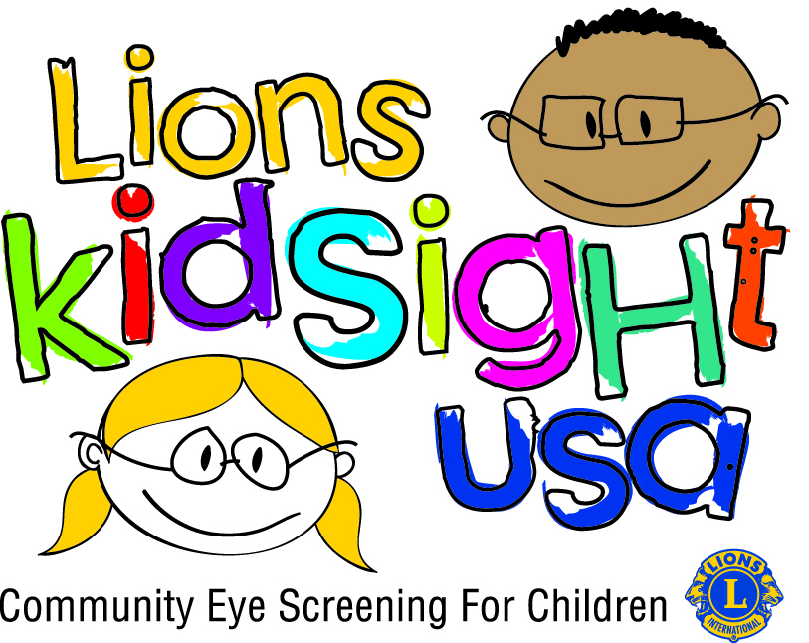

________ LIONS CLUB

VISION SCREENING RESULTS
Send to Vision Screening Coordinator

Name of School/Facility | Date of  Screening | #Screened  6M-8M | Referrals  6M-8M | #Screened  8M-6Y | Referrals  8M-6Y | #Screened  6Y-25Y | Referrals  6Y-25Y

